Operations Management, 10e, Global Edition (Heizer/Render)
Chapter 5 Design of Goods and Services

1) Regal Marine's attempts to keep in touch with customers and respond to the marketplace are made impossible because consumer tastes change and maritime engineering improves.
Answer: FALSE
Diff: 1
Topic: Goods and services selection
Objective: no LO

2) A product strategy may focus on differentiation, low-cost, or rapid response.
Answer: FALSE
Diff: 1
Topic: Goods and services selection
Objective: LO5-1

3) The goal of the product decision is to develop and implement a product strategy that meets the needs of the marketplace with a competitive advantage.
Answer: TRUE
Diff: 2
Topic: Goods and services selection
Objective: LO5-1

4) Political/legal change and economic change are both factors influencing market opportunities for new products.
Answer: TRUE
Diff: 1
Topic: Goods and services selection
Objective: LO5-1

5) The four phases of the product life cycle are incubation, introduction, growth, and decline.
Answer: FALSE
Diff: 2
Topic: Goods and services selection
Objective: LO5-1

6) In the maturity stage of the product life cycle, operations managers will be concerned with keeping sufficient capacity available for the product.
Answer: FALSE
Diff: 2
Topic: Goods and services selection
Objective: LO5-1

7) Relatively few new product ideas, perhaps only 1 in 250, become successfully marketed products.
Answer: TRUE
Diff: 2
Topic: Goods and services selection
Objective: LO5-1
8) 3M's goal is to produce 30% of its profit from products introduced in the last 4 years.
Answer: TRUE
Diff: 3
Topic: Goods and services selection
Objective: LO5-1

9) Computer-aided design (CAD) refers to the use of specialized computer programs to direct and control manufacturing equipment.
Answer: FALSE
Diff: 2
Topic: Generating new products
AACSB: Use of IT
Objective: LO5-2

10) Virtual reality technology can improve designs less expensively than the use of physical models or prototypes.
Answer: TRUE
Diff: 2
Topic: Generating new products
AACSB: Use of IT
Objective: LO5-2

11) Quality function deployment refers to first, determining what will satisfy the customer, and second, translating the customers' desires into a target design.
Answer: TRUE
Diff: 2
Topic: Product development
Objective: LO5-3

12) Robust design is a method that ensures that small variation in production or assembly does not adversely affect the product.
Answer: TRUE
Diff: 2
Topic: Issues for product design
Objective: LO5-5

13) Modular design exists only in tangible products; it makes no sense in services.
Answer: FALSE
Diff: 2
Topic: Issues for product design
Objective: LO5-5

14) One environmentally friendly approach to product design is to use lighter components.
Answer: TRUE
Diff: 2
Topic: Issues for product design
AACSB: Ethical Reasoning
Objective: no LO
15) An operations manager's most ethical activity is to enhance productivity while delivering desired goods and services. Unfortunately, this activity is not environmentally sound.
Answer: FALSE
Diff: 2
Topic: Issues for product design
AACSB: Ethical Reasoning
Objective: no LO

16) Two issues–viewing a product in terms of its impact on the entire economy and considering the life cycle of a product–combine to increase the likelihood of ethical decisions by managers.
Answer: TRUE
Diff: 2
Topic: Issues for product design
AACSB: Ethical Reasoning
Objective: no LO

17) Rapidly developing products and moving them to the market is part of time-based competition.
Answer: TRUE
Diff: 2
Topic: Time-based competition
Objective: LO5-4

18) The enhancement of existing products is an external product development strategy.
Answer: FALSE
Diff: 1
Topic: Time-based competition
Objective: LO5-4

19) The "make-or-buy" decision distinguishes between what an organization chooses to produce and what it chooses to purchase from suppliers.
Answer: TRUE
Diff: 2
Topic: Defining a product
Objective: LO5-5

20) Group technology enables the grouping of parts into families based on similar processing requirements.
Answer: TRUE
Diff: 1
Topic: Defining a product
Objective: LO5-5

21) A work order is a listing of the components, their description, and the quantity of each required to make one unit of the product.
Answer: FALSE
Diff: 2
Topic: Documents for production
Objective: LO5-6
22) An assembly drawing lists the operations necessary to produce the component.
Answer: FALSE
Diff: 2
Topic: Documents for production
Objective: LO5-6

23) An assembly chart shows an exploded view of the product, usually a three-dimensional or isometric drawing.
Answer: FALSE
Diff: 2
Topic: Documents for production
Objective: LO5-6

24) The customer may participate in the design of, and in the delivery of, services.
Answer: TRUE
Diff: 2
Topic: Service design
Objective: LO5-7

25) The moment-of-truth is the crucial moment between the service provider and the customer that exemplifies, enhances, or detracts from the customer's expectation.
Answer: TRUE
Diff: 2
Topic: Service design
Objective: LO5-7

26) The expected value of each course of action in a decision tree is determined by starting at the beginning of the tree (the left-hand side) and working toward the end of the tree (the right).
Answer: FALSE
Diff: 2
Topic: Application of decision trees to product design
Objective: LO5-8

27) Which of these statements regarding Regal Marine is true?
A) Product design is a critical decision for the firm.
B) Regal uses a three-dimensional CAD system to shorten product development time.
C) Regal still uses some wooden parts and hand-produces some components.
D) Regal's use of CAD has resulted in a superior product.
E) All of the above are true.
Answer: E
Diff: 2
Topic: Global company profile
Objective: no LO
28) Regal Marine
A) no longer builds boats with any wooden parts
B) designs and builds boat hulls by hand
C) treats the product design decision as critical to its success
D) gets its competitive advantage by being the low-cost producer of boats designed by others
E) designs several new boats each year, but contracts other firms for their manufacture
Answer: C
Diff: 2
Topic: Global company profile
Objective: no LO

29) The three major subdivisions of the product decision are
A) selection, definition, and design
B) goods, services, and hybrids
C) strategy, tactics, and operations
D) cost, differentiation, and speed of response
E) legislative, judicial, and executive
Answer: A
Diff: 2
Topic: Goods and services selection
Objective: LO5-1

30) Which of the following statements is not true?
A) Virtually all of Honda's sales (autos, motorcycles, generators, lawn mowers) are based on its outstanding engine technology.
B) Intel focuses on microprocessors.
C) Michelin focuses on tires.
D) Firms such as 3M establish goals for profitability from new products.
E) Dell Computers provides fast delivery to customers, but, in return, customers may only select from a limited choice of hardware configurations.
Answer: E
Diff: 2
Topic: Goods and services selection
Objective: LO5-1

31) Operations managers must be able to anticipate changes in which of the following?
A) product mix
B) product opportunities
C) the products themselves
D) product volume
E) all of the above
Answer: E
Diff: 2
Topic: Goods and services selection
Objective: LO5-1
32) In which stage of the product life cycle should product strategy focus on process modifications?
A) introduction
B) growth
C) maturity
D) decline
E) none of the above
Answer: A
Diff: 2
Topic: Goods and services selection
Objective: LO5-1

33) Which of the following would likely cause a change in market opportunities based upon levels of income and wealth?
A) economic change
B) sociological and demographic change
C) technological change
D) political change
E) legal change
Answer: A
Diff: 2
Topic: Goods and services selection
Objective: LO5-1

34) A product's life cycle is divided into four stages, which are
A) introduction, growth, saturation, and maturity
B) introduction, growth, stability, and decline
C) introduction, maturity, saturation, and decline
D) introduction, growth, maturity, and decline
E) none of the above
Answer: D
Diff: 1
Topic: Goods and services selection
Objective: LO5-1

35) When should product strategy focus on forecasting capacity requirements?
A) at the introduction stage of the product life cycle
B) at the growth stage of the product life cycle
C) at the maturity stage of the product life cycle
D) at the decline stage of the product life cycle
E) none of the above
Answer: B
Diff: 1
Topic: Goods and services selection
Objective: LO5-1
36) Which of the following statements regarding product life cycle and profitability is true?
A) Profit is highest in the growth life cycle phase because the product is new and unique.
B) Profit is lowest in the growth stage of the life cycle because costs are so high.
C) Profit is at its greatest in the decline stage of the product life cycle.
D) Breakeven is attained in the growth stage of the product life cycle.
E) Cash flow turns positive in the maturity phase.
Answer: C
Diff: 2
Topic: Goods and services selection
Objective: LO5-1

37) The analysis tool that helps determine what products to develop, and by what strategy, by listing products in descending order of their individual dollar contribution to the firm is
A) decision tree analysis
B) Pareto analysis
C) breakeven analysis
D) product-by-value analysis
E) product life cycle analysis
Answer: D
Diff: 2
Topic: Goods and services selection
Objective: LO5-1

38) In which stage of the product life cycle should product strategy focus on improved cost control?
A) introduction
B) growth
C) maturity
D) decline
E) none of the above
Answer: C
Diff: 2
Topic: Goods and services selection
Objective: LO5-1

39) __________ is used to rank a company's products to determine which products represent the best use of the firm's resources, or, perhaps, to determine which products are to be eliminated.
A) Value analysis
B) Value engineering
C) Financial analysis
D) Product-by-value analysis
E) Product cost justification
Answer: D
Diff: 1
Topic: Goods and services selection
Objective: LO5-1
40) Which of the following represent an opportunity for generating a new product?
A) understanding the customer
B) demographic change, such as decreasing family size
C) changes in professional standards
D) economic change, such as rising household incomes
E) All of the above are such opportunities.
Answer: E
Diff: 2
Topic: Generating new products
Objective: LO5-2

41) What % of sales from new products is indicative of industry leaders?
A) 50%
B) below 25%
C) 25 to 35%
D) above 60%
E) 35 to 45%
Answer: A
Diff: 2
Topic: Generating new products
Objective: LO5-2

42) Which of the following is true regarding value engineering?
A) Value engineering occurs only after the product is selected and designed.
B) Value engineering is the same as value analysis.
C) Value engineering is oriented toward improvement of design.
D) Value engineering occurs during production when it is clear the product is a success.
E) Value engineering can save substantial amounts of product cost, but quality suffers.
Answer: C
Diff: 2
Topic: Product development
Objective: LO5-3

43) Reducing the complexity of a product and improving a product's maintainability for use are activities of
A) Product Lifecycle Management (PLM)
B) product-by-value-analysis
C) manufacturability and value engineering
D) organizing for product development
E) design for destruction (DFD)
Answer: C
Diff: 2
Topic: Product development
Objective: LO5-3
44) Quality function deployment (QFD)
A) determines what will satisfy the customer
B) translates customer desires into the target design
C) is used early in the design process
D) is used to determine where to deploy quality efforts
E) all of the above
Answer: E
Diff: 2
Topic: Product development
Objective: LO5-3

45) A graphic technique for defining the relationship between customer desires and product/service is
A) Product Lifecycle Management
B) the House of Quality
C) the moment of truth
D) the assembly drawing
E) the product development team
Answer: B
Diff: 2
Topic: Product development
Objective: LO5-3

46) One result of concurrent engineering in product design is
A) speedier product development
B) lower quality
C) less customer demand
D) higher costs
E) all of the above
Answer: A
Diff: 2
Topic: Product development
Objective: LO5-3

47) Product development teams are also known as
A) the Japanese approach
B) concurrent engineering
C) QFD
D) the traditional U.S. approach
E) none of the above
Answer: B
Diff: 2
Topic: Product development
Objective: LO5-3
48) When developing the Trident Splash, Cadbury faced design problems overcome by
A) manufacturability and value engineering
B) QFD
C) the House of Quality
D) CAD
E) concurrent engineering
Answer: A
Diff: 2
Topic: Product development
Objective: LO5-3

49) The Japanese method of organizing for product design features
A) teams
B) product managers (champions)
C) distinct departments with assigned tasks
D) a single organization without subdivision or individual teams
E) none of the above
Answer: D
Diff: 2
Topic: Product development
Objective: LO5-3

50) Manufacturability and Value Engineering has which of the following benefits?
I. Reduced complexity of the product
II. Reduction of environmental impact
III. Additional standardization of components
IV. Robust design
V. Improved job design and safety
A) I, III, V
B) II, IV
C) I, III, IV
D) IV
E) I, II, III, IV, V
Answer: E
Diff: 2
Topic: Product development
Objective: LO5-3

51) Which of the following is true regarding computer-aided design?
A) It is too expensive to use in most manufacturing and design settings.
B) It is an old technology
C) It results in longer development cycles for virtually all products.
D) It is the use of computers to interactively design products and prepare engineering documentation.
E) All of the above are true.
Answer: D
Diff: 2
Topic: Issues for product design
AACSB: Use of IT
Objective: LO5-5
52) Which of the following is true concerning CAD?
A) Accurate information flows to other departments.
B) Most product costs are determined at the design stage.
C) Design options are easier to review before final commitments are made.
D) Virtually all products have their development cycle shortened.
E) All of the above are true.
Answer: E
Diff: 2
Topic: Issues for product design
AACSB: Use of IT
Objective: LO5-5

53) A manufacturing plant uses a computerized scanner to measure the inner diameters of the belts it produces to ensure they are within the specifications. This is referred to as
A) CAM
B) CAD
C) QFD
D) DFMA
E) STEP
Answer: A
Diff: 2
Topic: Issues for product design
Objective: LO5-5

54) Black & Decker's hand-powered tools and Hewlett-Packard's printer business are examples of using enhancements and migrations of existing products to build on a __________.
A) product template
B) product pulpit
C) product platform
D) product dais
E) product foundation
Answer: C
Diff: 2
Topic: Time-based competition
Objective: LO5-4

55) An operations manager's most ethical activity is
A) to enhance productivity while delivering desired goods and services
B) to use less energy
C) to use more recycled ingredients
D) to use less harmful ingredients
E) to follow appropriate OSHA and EPA regulations
Answer: A
Diff: 2
Topic: Issues for product design
AACSB: Ethical Reasoning
Objective: no LO
56) Bridget's Hamburger Stand uses only 7 ingredients but offers 15 different burgers. This process is known as
A) Robust Design
B) QFD
C) Modular Design
D) CAD
E) Value analysis
Answer: C
Diff: 2
Topic: Issues for product design
Objective: LO5-5

57) Value analysis takes place
A) when the product is selected and designed
B) during the initial stages of production when something needs to be done to assure product success
C) when the product is first conceived
D) during the production process when it is clear the new product is a success
E) when the product cost is very low
Answer: D
Diff: 2
Topic: Issues for product design
Objective: LO5-5

58) Which of the following makes products that are friendlier to the environment?
A) using less materials
B) more recycled materials
C) using less energy
D) using less harmful ingredients
E) all of the above
Answer: E
Diff: 2
Topic: Issues for product design
AACSB: Ethical Reasoning
Objective: no LO

59) One method used to determine a product's total environmental impact from conversion of inputs through production and to disposal is
A) QFD
B) Design for manufacturability
C) Value Analysis
D) Life Cycle Assessment
E) C and D
Answer: E
Diff: 2
Topic: Issues for product design
Objective: LO5-3
60) Products are more "environmentally friendly" when they are made
A) using cheaper materials
B) using less energy
C) according to OSHA standards
D) where environmental regulations are lax
E) more difficult to disassemble
Answer: B
Diff: 1
Topic: Issues for product design
AACSB: Ethical Reasoning
Objective: no LO

61) An operations manager's ethical responsibilities
A) are limited to the production phase of product life cycle
B) are limited to following published laws and regulations
C) extend from design, to production, to final destruction/disposition of a product
D) do not include being efficient with the firm's resources
E) need not consider a product design's impact on the entire economy
Answer: C
Diff: 2
Topic: Issues for product design
AACSB: Ethical Reasoning
Objective: no LO

62) The change in cell-phone model life cycles from 2 years to under 6 months is the result of
A) time-based competition
B) design for manufacturability
C) life cycle assessment
D) value analysis
E) all of the above
Answer: A
Diff: 2
Topic: Time-based competition
Objective: LO5-4

63) Which of the following is an example of an external product development strategy?
A) new internally developed products
B) enhancements to existing products
C) alliances
D) migrations of existing products
E) All of the above are examples of internal product development strategy.
Answer: C
Diff: 2
Topic: Time-based competition
Objective: LO5-4
64) Which of the following product development strategies has the highest risk?
A) acquiring the developer
B) alliances
C) joint ventures
D) new internally developed products
E) purchasing technology
Answer: D
Diff: 2
Topic: Time-based competition
Objective: LO5-4

65) An engineering drawing shows the
A) dimensions, tolerances, materials, and finishes of a component
B) dimensions, tolerances, cost, and sales or use volume of a component
C) materials, finishes, machining operations, and dimensions of a component
D) cost, materials, tolerances, and lead-time for a component
E) cost, dimensions, and machining operations for a component
Answer: A
Diff: 2
Topic: Defining the product
Objective: LO5-5

66) The dimensions, tolerances, materials, and finishes of a component are typically shown on a(n)
A) assembly chart
B) engineering drawing
C) bill of material
D) assembly drawing
E) route sheet
Answer: B
Diff: 2
Topic: Defining a product
Objective: LO5-5

67) Which of the following does not result from the effective use of group technology?
A) reduced tooling setup time
B) simplified training
C) reduced raw materials and purchases
D) simplified production planning and control
E) improved layout, routing, and machine loading
Answer: B
Diff: 2
Topic: Defining a product
Objective: LO5-5
68) Which of the following typically shows the components, their description, and the quantity of each required to make one unit of a product?
A) an engineering drawing
B) an assembly drawing
C) a bill of material
D) an assembly chart
E) a route sheet
Answer: C
Diff: 2
Topic: Documents for production
Objective: LO5-6

69) Which of the following shows in schematic form how a product is assembled?
A) an engineering drawing
B) an assembly routing
C) an assembly chart
D) a route sheet
E) a process sheet
Answer: C
Diff: 2
Topic: Documents for production
Objective: LO5-6

70) The components, their description, and the quantity of each required to make one unit of a product are documented on
A) a group technology listing
B) a route sheet
C) a bill of materials
D) an engineering drawing
E) none of the above
Answer: C
Diff: 2
Topic: Documents for production
Objective: LO5-6

71) A route sheet provides a(n)
A) exploded view of the product
B) instruction to make a given quantity of a particular item
C) schematic showing how the product is assembled
D) sequence of operations necessary to produce the component
E) set of detailed instructions about how to perform a task
Answer: D
Diff: 2
Topic: Documents for production
Objective: LO5-6
72) Group technology requires that
A) each component be identified by a coding scheme that specifies the type of processing and the parameters of the processing
B) a specific series of engineering drawings be prepared
C) all bills of material be prepared using the same format
D) engineering change notices be linked to each of the bills of material and engineering notices
E) the final products be standardized
Answer: A
Diff: 2
Topic: Defining a product
Objective: LO5-5

73) An assembly drawing
A) shows, in schematic form, how the product is assembled
B) shows an exploded view of the product
C) lists the operations, including assembly and inspection, necessary to produce the component with the material specified in the bill of material
D) provides detailed instructions on how to perform a given task
E) describes the dimensions and finish of each component
Answer: B
Diff: 1
Topic: Documents for production
Objective: LO5-6

74) An assembly chart
A) shows graphically how the product is assembled
B) shows an exploded view of the product
C) lists the operations, including assembly and inspection, necessary to produce the component with the material specified in the bill of material
D) provides detailed instructions on how to perform a given task
E) describes the dimensions and finish of each component
Answer: A
Diff: 1
Topic: Documents for production
Objective: LO5-6

75) A process sheet is a type of
A) assembly drawing
B) assembly chart
C) route sheet
D) work order
E) bill of materials
Answer: C
Diff: 2
Topic: Documents for production
Objective: LO5-6
76) Which of the following documents lists the operations (including assembly and inspection) necessary to produce the component with the material specified in the bill of material?
A) an engineering drawing
B) an assembly drawing
C) a route sheet
D) an assembly chart
E) an operations chart
Answer: C
Diff: 2
Topic: Documents for production
Objective: LO5-6

77) A restaurant kitchen contains a wall poster that shows, for each sandwich on the menu, a sketch of the ingredients and how they are arranged to make the sandwich. This is an example of a(n)
A) assembly drawing
B) route sheet
C) bill of materials
D) work order
E) virtual technology
Answer: A
Diff: 2
Topic: Documents for production
Objective: LO5-6

78) The document for production that gives the instruction to make a given quantity of a particular item, usually to a given schedule, is
A) the work order
B) the route sheet
C) the bill of information
D) the assembly chart
E) the value analysis
Answer: A
Diff: 2
Topic: Documents for production
Objective: LO5-6

79) Which of the following is not a service design technique used to reduce cost?
A) increasing customer interaction
B) delaying customization
C) automation
D) modularizing the product
E) reducing customer interaction
Answer: A
Diff: 2
Topic: Service design
Objective: LO5-7
80) Which of the following examples involves customer participation in the design of the service?
A) investing in a mutual fund
B) buying a life insurance policy
C) providing the stockbroker with the desired distribution of the portfolio
D) seeing a movie at the theater
E) eating at a fast-food restaurant
Answer: C
Diff: 2
Topic: Service design
AACSB: Communication
Objective: LO5-7

81) Modern ATM machines are an automated example of a service design that
A) reduces customer interaction
B) modularizes the service
C) delays service customization
D) has no moment of truth
E) has insufficient quality function deployment
Answer: A
Diff: 2
Topic: Service design
Objective: LO5-7

82) For a full-time college student, which of the following moments of truth exemplifies the customer's standard expectations?
A) Your advisor made you wait, even though you had an appointment.
B) You had to visit more than once to reach your academic advisor.
C) Your advisor was competent, helpful, and understanding.
D) Your advisor failed to keep her appointment with you.
E) Your advisor offered to work with you after regular work hours.
Answer: C
Diff: 3
Topic: Service design
Objective: LO5-7

83) Which service design technique(s) would ordinarily not be appropriate for full-service restaurant meals?
A) modularizing the product
B) customization as late in the process as possible
C) reducing customer interaction
D) the moment of truth
E) All of the above are appropriate.
Answer: C
Diff: 2
Topic: Service design
Objective: LO5-7
84) Which of the following scenarios illustrates a moment that exceeds the customer's expectations?
A) an express mail service that guarantees overnight delivery
B) a flight attendant that responds shortly after being called
C) a hairdresser that cuts your hair at the right length
D) a professor that contacts people in several companies to find you a job
E) a bank that sends you monthly account statements
Answer: D
Diff: 3
Topic: Service design
Objective: LO5-7

85) Which of the following scenarios illustrates a moment that meets the customer's expectations?
A) a sales clerk that called you by your name on your second visit to the store
B) an express mail service that guarantees same day delivery
C) a flight attendant that responds shortly after being called
D) a professor that contacts people in several companies to find you a job
E) a sales clerk at the clothing store that asked you to wait for a minute as soon as a wealthy-looking customer entered the store
Answer: C
Diff: 3
Topic: Service design
Objective: LO5-7

86) The role of decision trees in product design is
A) to rank products in descending order of their dollar contribution to the firm
B) to better understand the customers' wants
C) to calculate the expected value of each course of action
D) to calculate the value of quality function deployment
E) to calculate the value of the moment of truth
Answer: C
Diff: 1
Topic: Application of decision trees to product design
Objective: LO5-8

87) Payoffs, alternatives, and expected monetary values are terms associated with
A) virtual reality
B) Product Lifecycle Management
C) Quality Function Deployment
D) decision trees
E) make-or-buy analysis
Answer: D
Diff: 1
Topic: Application of decision trees to product design
Objective: LO5-8
88) Regal Marine's use of __________ has reduced product development time and reduced problems with tooling and production.
Answer: CAD or Computer-aided Design
Diff: 2
Topic: Global company profile
AACSB: Use of IT
Objective: no LO

89) In the __________ phase of the product life cycle, the product design has begun to stabilize.
Answer: growth
Diff: 2
Topic: Goods and services selection
Objective: LO5-1

90) __________ lists products in descending order of the individual dollar contribution to the firm.
Answer: Product-by-value analysis
Diff: 2
Topic: Goods and services selection
Objective: LO5-1

91) __________ is a process for determining customer requirements and translating them into attributes that each functional area can understand and act upon.
Answer: Quality Function Deployment or QFD
Diff: 2
Topic: Product development
Objective: LO5-3

92) The __________ is a part of the quality function deployment process that utilizes a planning matrix to relate customer "wants" to "how" the firm is going to meet those "wants."
Answer: House of Quality
Diff: 2
Topic: Product development
Objective: LO5-3

93) __________ provides a format allowing the electronic transmittal of three-dimensional data.
Answer: Standard for the exchange of product data or STEP
Diff: 2
Topic: Generating new products
AACSB: Use of IT
Objective: LO5-5

94) The use of information technology to control machinery is called __________.
Answer: computer-aided manufacturing or CAM
Diff: 2
Topic: Generating new products
AACSB: Use of IT
Objective: LO5-5
95) If a design can be produced to requirements even when the production process has unfavorable conditions, the design is said to be __________.
Answer: robust
Diff: 2
Topic: Issues for product design
Objective: LO5-5

96) Products or services designed in easily segmented components are known as __________.
Answer: modular designs
Diff: 2
Topic: Issues for product design
Objective: LO5-5

97) __________ reviews successful products for improvement during the production process.
Answer: Value analysis
Diff: 2
Topic: Issues for product design
Objective: LO5-5

98) Sensitivity to a wide variety of environmental issues in production processes is referred to as __________.
Answer: green manufacturing
Diff: 2
Topic: Issues for product design
AACSB: Ethical Reasoning
Objective: LO5-5

99) To view product design from a "systems" perspective, managers must view a product in terms of its impact on __________.
Answer: the entire economy
Diff: 1
Topic: Issues for product design
Objective: LO5-5

100) Boeing's use of epoxy composites and titanium graphite laminate represent the ethical and environmentally friendly concept of __________.
Answer: using lighter components
Diff: 1
Topic: Issues for product design
AACSB: Ethical Reasoning
Objective: LO5-5

101) Rapidly developing products and moving them to the market is referred to as __________.
Answer: time-based competition
Diff: 1
Topic: Time-based competition
Objective: LO5-4
102) A drawing that shows the dimensions, tolerances, materials, and finishes of a component is a(n) __________.
Answer: engineering drawing
Diff: 1
Topic: Documents for production
Objective: LO5-6

103) A listing of the components, their description, and the quantity of each required to make one unit of product is the __________.
Answer: bill of materials
Diff: 2
Topic: Documents for production
Objective: LO5-6

104) Black & Decker's hand-powered tools and Hewlett-Packard's printer business are examples of using enhancements and migrations of existing products to build on __________.
Answer: product platforms
Diff: 2
Topic: Time-based competition
Objective: LO5-4

105) An exploded view of the product is a(n) __________.
Answer: assembly drawing
Diff: 2
Topic: Documents for production
Objective: LO5-6

106) The __________ is the crucial moment between the service provider and the customer that exemplifies, enhances, or detracts from the customer's expectations.
Answer: moment-of-truth
Diff: 2
Topic: Service design
Objective: LO5-7

107) In analyzing product design decisions, decision trees determine the __________ of each course of action.
Answer: expected value or EMV
Diff: 2
Topic: Application of decision trees to product design
Objective: LO5-8

108) What is the objective of the product decision?
Answer: To develop and implement a product strategy that meets the demands of the marketplace with a competitive advantage.
Diff: 2
Topic: Goods and services selection
Objective: LO5-2
109) What is a product-by-value analysis, and what type of decision does it help managers make?
Answer: A product-by-value analysis lists products in descending order of their individual dollar contribution to the firm, as well as the total annual dollar contribution of the product. It helps managers evaluate possible strategies for each product. The product-by-value report focuses management's attention on the strategic direction for each product.
Diff: 2
Topic: Goods and services selection
Objective: LO5-2

110) Identify the factors that influence new product opportunities.
Answer: Factors that influence new product opportunities include economic change, sociological and demographic change, technological change, political change, and other changes brought about through market practice, professional standards, suppliers, and distributors.
Diff: 2
Topic: Goods and services selection
Objective: LO5-2

111) "With respect to the product decision, managers must be able to accept risk and tolerate failure." Comment on why this is a necessary hazard in making new product decisions, given all the powerful tools and carefully built systems that support that decision.
Answer: The vast majority of new product ideas do not become marketable products, and most marketable products are failures. Perhaps 500 designs accompany each success.
Diff: 2
Topic: Goods and services selection
Objective: LO5-2

112) Identify the general benefits derived from CAD.
Answer: Product quality (better adherence to standards); shorter design time; production cost reductions (from better design); database availability (for new products); and new range of capabilities (easy programming of CNC machines).
Diff: 2
Topic: Generating new products
AACSB: Use of IT
Objective: LO5-5

113) Is it possible for a product's life cycle stage to affect its product strategy? In particular, describe how one product in growth and another in maturity might have different product strategies.
Answer: There is no reason for the strategy to be static through the life cycle stages. Organizations often treat new products differently than older ones, in terms of support for changes, aggressiveness in pursuit of market, etc. In particular, growth is associated with stabilization of design, and with ensuring that sufficient capacity exists. Maturity is a time for high-volume operations and cost control.
Diff: 2
Topic: Goods and services selection
Objective: LO5-1
114) Describe the benefits associated with value engineering.
Answer: Benefits include immediate cost reductions; reduced product complexity; additional standardization of components; improvement of functional aspects of the products; improved job design and job safety; improved maintainability (serviceability) of the product; and robust design.
Diff: 2
Topic: Product development
Objective: LO5-2

115) Provide some examples of recent product changes, i.e. new products that are replacing older ones.
Answer: Answers will vary. The list in the text includes: TV to HDTV, radio to satellite radio, coffee shops to Starbucks lifestyle coffee, traveling circuses to Cirque du Soleil, land lines to cell phones, cell phone to Blackberry, Walkman to iPod, and mops to Swiffers.
Diff: 2
Topic: Generating new products
AACSB: Reflective Thinking
Objective: LO5-1

116) What is quality function deployment (QFD)?
Answer: QFD refers to determining what will satisfy the customer and translating those customer desires into the target design.
Diff: 1
Topic: Product development
Objective: LO5-3

117) Identify the steps involved in building the House of Quality.
Answer: Identify customers' wants, identify product/service attributes, relate the customers' wants to the product/service how's, conduct an evaluation of competing products, develop performance specifications for product or service how's, and assign how's to the appropriate place in the transformation process.
Diff: 2
Topic: Product development
Objective: LO5-3

118) Explain the difference between value analysis and value engineering.
Answer: Value engineering is concerned with reducing cost and improving function in a preproduction setting; value analysis, with similar aims, takes place during production, when the product has shown that it will succeed. Techniques are similar.
Diff: 2
Topic: Product development and Issues for product design
Objective: LO5-2
119) Aggressive new product development requires that organizations build structures internally that contain what features?
Answer: They should have open communication with customers, innovative organizational cultures, aggressive R&D, strong leadership, formal incentives, and training.
Diff: 3
Topic: Generating new products
AACSB: Communication
Objective: LO5-2

120) What two issues should be considered in combination in order to enhance the likelihood of ethical decision in the realm of product design? Why is each important?
Answer: The two issues are (1) view product design from a "systems" perspective, and (2) consider the life cycle of the product. The first issue causes managers to go beyond "what is best or cheapest for the firm?" The second causes managers to address environmental concerns over the life of the product, not just at time of manufacture.
Diff: 2
Topic: Issues for product design
AACSB: Ethical Reasoning
Objective: LO5-2

121) Identify the specific guidelines that can help an operations manager achieve environmentally friendly designs.
Answer: Specifically, the following ideas are presented in the text: make products recyclable, use recycled material, use less harmful ingredients, use lighter components, use less energy, and use less material.
Diff: 2
Topic: Issues for product design
AACSB: Ethical Reasoning
Objective: LO5-2

122) What are some of the benefits from using environmental teams for product design?
Answer: Environmental teams help develop safe and more environmentally sound products, minimize the waste of raw materials and energy, differentiate products from competition, reduce environmental liabilities, increase cost-effectiveness of complying with environmental regulations, and help the organization be recognized as a good corporate citizen.
Diff: 2
Topic: Issues for product design
AACSB: Ethical Reasoning
Objective: LO5-2
123) Discuss the advisability of using modular assemblies in manufacturing. (What are the advantages and disadvantages?) To what extent can these arguments be applied to service products?
Answer: Modules are easily segmented components; they add flexibility to production and marketing; allows mix-and-match of components (customization at point of customer contact). Use of modules usually means fewer parts, less design and tooling expense. Disadvantages include using a module in a product for which a more specific component would have been better. Modules exist in services, as in fast-food meals built to customer specification.
Diff: 3
Topic: Issues for product design
Objective: LO5-2

124) What is time-based competition?
Answer: Time-based competition is competition that is based on time. It involves rapid development of products, fast introduction to the marketplace. Often, the first company into production may have its product adopted as the "standard."
Diff: 2
Topic: Time-based competition
Objective: LO5-4

125) State the benefits of implementing group technology.
Answer: Benefits include improved design; reduced raw materials and purchases; simplified production planning and control; improved routing and machine loading; reduced tooling setup time, work-in-process, and production time; and development of work cells.
Diff: 2
Topic: Defining a product
Objective: LO5-5

126) Identify the external product development strategies; describe each in a sentence or two.
Answer: The external product development strategies include alliances, joint ventures, and purchase of technology or expertise by acquiring the developer. Alliances are cooperative agreements that allow firms to remain independent, but use complementing strengths to pursue strategies consistent with their individual missions. Joint ventures are combined ownership to pursue new products or markets. Purchasing technology or expertise is usually accomplished by acquiring entrepreneurial firms that have already developed the technology that fits the mission. The issue then becomes fitting the purchased organization, its technology, and its product line into the buying firm, rather than a product development issue.
Diff: 2
Topic: Time-based competition
Objective: LO5-4
127) How does configuration management manifest itself when you ask for service on your automobile?
Answer: Configuration management is used by every automobile manufacturer to track all of the changes between and during a model year. To be specific about the part that is needed, the VIN (vehicle identification number) is often used.
Diff: 2
Topic: Documents for production
Objective: LO5-6

128) Briefly explain how Product Lifecycle Management (PLM) impacts product design.
Answer: PLM is an umbrella of software programs that attempts to bring together many phases of product design and manufacture. PLM products often start with product design (CAD/CAM); move on to design for manufacture and assembly (DFMA); and then into product routing, materials, layout, assembly, maintenance and even environmental issues.
Diff: 2
Topic: Documents for production
Objective: LO5-6

129) Identify the four methods of service design that can reduce costs and enhance the product.
Answer: Customizing as late in the process as possible; modularizing the product; identifying the service parts that lend themselves to automation or reduced customer interaction; and focusing design on the moment of truth.
Diff: 2
Topic: Service design
Objective: LO5-7
130) JDI, Inc. is trying to decide whether to make-or-buy a part (#J-45FPT). Purchasing the part would cost them $1.50 each. If they design and produce it themselves, it will result in a per unit cost of $0.75. However, the design investment would be $50,000. Further, they realize that for this type of part, there is a 30% chance that the part will need to be redesigned at an additional cost of $50,000. Regardless of whether they make-or-buy the part, JDI will need 100,000 of these parts. Using decision trees analysis and EMV, what should JDI do? Show the decision tree.
Answer: Since the expected values represent costs, JDI should select the lowest expected value, and make the part. Its expected monetary value (cost) is $140,000 versus $150,000 for the buy decision.

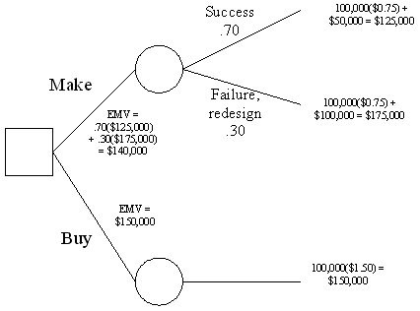
Diff: 2
Topic: Application of decision trees to product design
AACSB: Analytic Skills
Objective: LO5-8

131) Tri-products is trying to decide whether to make-or-buy an accessory item for one of their products. It is projected that this item will sell for $10 each. If the item is outsourced, there is virtually no cost other than the $6 per unit that they would pay their supplier. Internally, they have two choices. Process A requires an investment of $120,000 for design and equipment, but results in a $4 per unit cost. Process B requires only a $100,000 investment, but its per unit cost is $5. Regardless of whether the item is subcontracted or produced internally, there is a 50% chance that they will sell 50,000 units, and a 50% chance that they will sell 100,000 units. Draw the decision tree appropriate to the alternatives and outcomes stated. Using decision trees and EMV, what is their best choice?
Answer: Process A promises the highest profit with an EMV of $330,000.

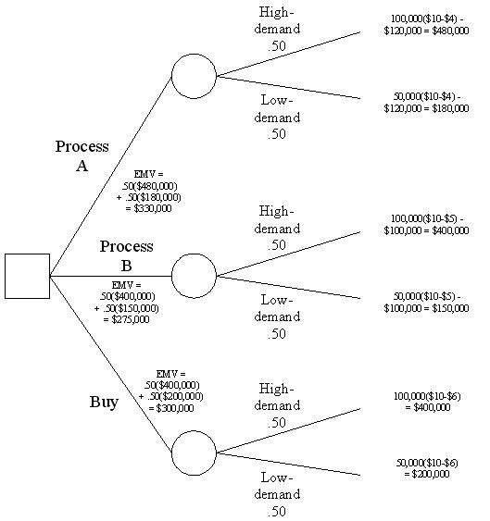

Diff: 2
Topic: Application of decision trees to product design
AACSB: Analytic Skills
Objective: LO5-8
132) A company manufactures specialty pollution-sensing devices for the offshore oil industry. One particular device has reached maturity, and the company is considering whether to replace it with a newer model. Technologies have not changed dramatically, so the new device would have similar functionality to the existing one, but would be smaller and lighter in weight. The firm's three choices are: keep the old model; design a replacement device with internal resources; and purchase a new design from a firm that is one of its suppliers. The market for these devices will be either "receptive" or "neutral" of the replacement model. The financial estimates are as follows: Keeping the old design will yield a profit of $6 million dollars. Designing the replacement internally will yield $10 million if the market is "receptive," but a $3 million loss if the market is "neutral." Acquiring the new design from the supplier will profit $4 million under "receptive," $1 million under "neutral." The company feels that the market has a 70 percent chance of being "receptive" and a 30 percent chance of being "neutral." Draw the appropriate decision tree. Calculate expected value for all courses of action. What action yields the highest expected value?

Answer:
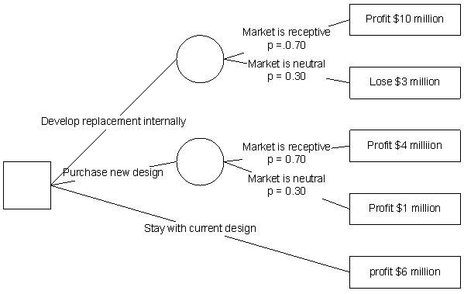

The three expected monetary values are:
Develop replacement internally: $10,000,000 x .7 -$3,000,000 x .3 = $6.1 million
Purchase new design: $4,000,000 x .7 + $1,000,000 x .3 = $3.1 million
Stay with current design: $6 million
The company should choose the highest value, and develop a replacement product design with internal resources.
Diff: 2
Topic: Application of decision trees to product design
AACSB: Analytic Skills
Objective: LO5-8
133) A swim club is designing a new pool to replace its old pool. The new pool would need to last for 10 years since the club is planning on relocating after 10 years. A concrete shell would cost $100,000 and last for all 10 years. Another option is to install a vinyl liner that would cost only $75,000 to install. However, the vinyl is not guaranteed to last for all 10 years, and has a 33% chance of breaking down. Repair of the vinyl would cost $40,000 and would extend the life of the vinyl liner to the 10 year mark. If both options are acceptable to the swim club, which one minimizes their cost?
Answer:
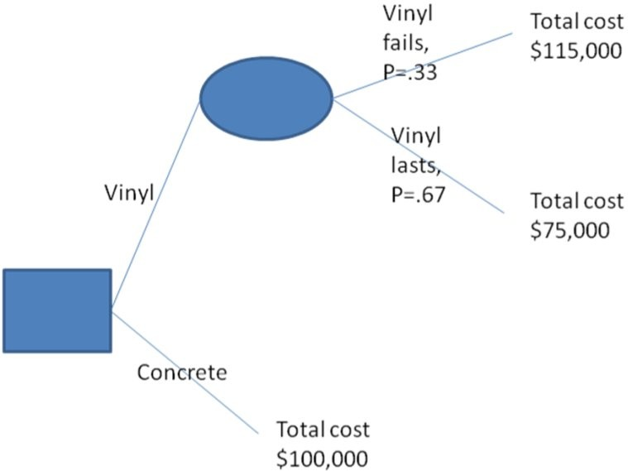

EMV(in thousands) of vinyl is .33(115)+.67(75) = $88.2
EMV (in thousands) of concrete is $100
The club should install the vinyl option to minimize cost
Diff: 2
Topic: Application of decision trees to product design
AACSB: Analytic Skills
Objective: LO5-8
134) A company producing apps for a social networking site is deciding which path to pursue. The first is to create an app that has universal appeal but faces a crowded market. This app, A, would have sales of 100,000 copies at $1 each under ideal conditions, but under tough conditions would have sales of only 60,000 copies at $.80 each. The other app, B, would have sales of 500,000 units at $.50 each under ideal conditions but sales would be reduced to 10,000 units at $.50 each under tough conditions. If ideal and rough conditions occur with the same frequency, which app should the company produce? Note- both apps cost the same to develop.
Answer:
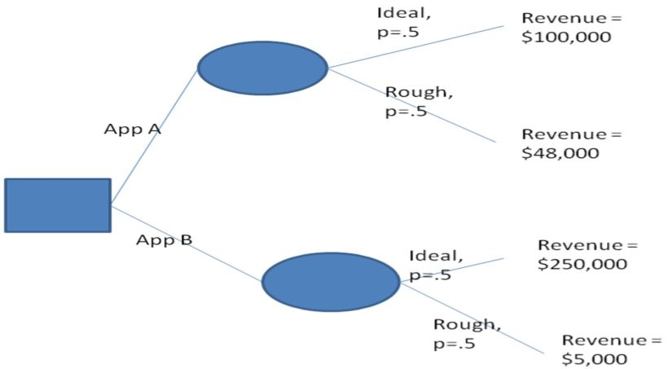

EMV(in thousands) of App A is .5(100)+.5(48) = $74
EMV(in thousands) of App B is .5(250)+.5(5) = $127.5
The company should pursue App B to maximize expected revenue.
Diff: 2
Topic: Application of decision trees to product design
AACSB: Analytic Skills
Objective: LO5-8
135) A company is deciding if it should design an advertising system for use on Twitter©. The first option is to skip out on designing, with no net costs or gains. The second option is System A, which would result in additional sales of either $50,000 under good conditions or $10,000 under bad conditions. The final choice is System B, which would increase sales by $20,000 under both good and bad conditions. Suppose that good conditions are twice as likely as bad conditions. Which option should the company pursue if developing a system costs $25,000?
Answer:
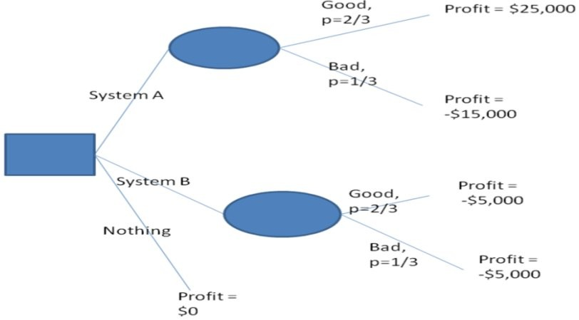

EMV of System A is 2/3(25000)+(-15,000)/3=$11666.67
EMV of System B is -$5,000
EMV of nothing is $0.
Thus the company should develop system A.
Diff: 2
Topic: Application of decision trees to product design
AACSB: Analytic Skills
Objective: LO5-8
136) A company looking for venture capitalist funding is deciding on the design of its operating system for its new phone. The first option is to simply buy the OS from another company. This would result in sales of either 10,000 units if the market is not crowded with similar phones or sales of only 3,000 units if the market is crowded. If the company decides to design its own OS the phone would have sales of 70,000 units if the OS was popular but sales of only 2,000 if the OS was a failure. Suppose that to recoup the cost of designing their own OS the company would need to sell twice as many phones as when they simply buy the OS for the profit from the scenarios to be equal. Which option should the company choose if the probability that the market is/ is not crowded is 50% and the probability that the OS is popular is 75%?
Answer:
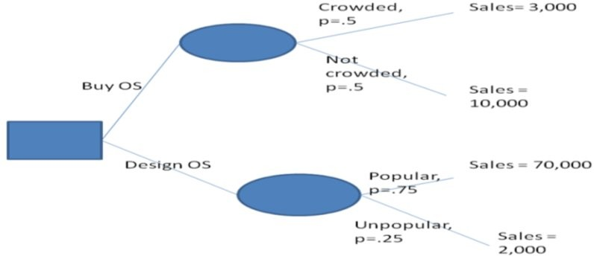

EMV of buy OS is .5(3000)+.5(10000)=6500 units
EMV of design OS is .75(70000)+.25(2000)=53000 units
However, the firm needs to sell twice as many designed OS phones as bought OS phones for equal profit, so that means 6500 bought OS phones are worth 13000 designed OS phones. Since 13,000 is less than the 53,000 expected sales from the designed OS, the company should design their own OS.
Diff: 2
Topic: Application of decision trees to product design
AACSB: Analytic Skills
Objective: LO5-8
137) A company is deciding if it should do design of a product in-house or outsource the design. If outsourced the cost for a low bidder would be $40,000 and the cost for an expensive bidder $100,000. To do the design in-house would require over-time for an already stretched design team with total costs of $70,000. If all three designs (in-house, low bid, high bid) are equal in quality and the likelihood of finding a low bidder is 60% (meaning that 40% of the time the firm will have to hire the expensive bidder), should the company outsource design or do it in-house?
Answer:
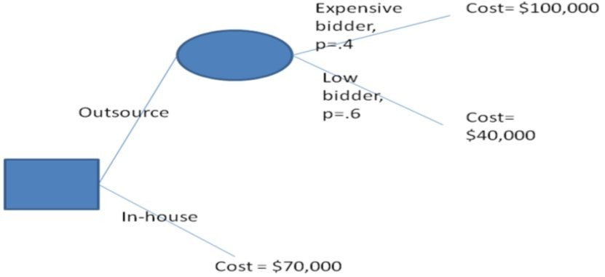

EMV of outsource is .4(100,000)+.6(40,000)=$64,000
EMV of in-house is $70,000
Thus to minimize costs the firm should outsource the design.
Diff: 2
Topic: Application of decision trees to product design
AACSB: Analytic Skills
Objective: LO5-8

